INDIAN SCHOOL ALWADI ALKABIR
DEPARTMENT OF SOCIAL SCIENCE
PRE-MID TERM ASSESSMENT: 2023-24
ANSWER KEY

CLASS: VII Max: Marks: 30
Date: 28/05/2023 Time: 1Hour.
General Instructions: -
1. Ensure that you have written your name and roll number correctly.
2. This Question paper has two parts, Section A (History)B (Geography).
3. All questions are compulsory.
4. All the answers must be correctly numbered as in the question paper in the Answer sheet
provided

 | SECTION - A (HISTORY) 10 Marks
I | Choose the correct option: - | 1 Marks
1 | The professionals who copied down the manuscripts are called.  (a) Warrior (b) Historian (c) Al-Idrisi (d) Scribes | 1 Mark
II | Fill in the blanks: - | 2 Marks
2 | Ziyauddin Barani was a ____________century chronicler.  Fourteenth-century | 1 Mark
3 | Amir Khusrau was a ____________.  Poet. | 1 Mark
III | Answer in one or two sentences: - | 2 Marks
4 | Who is a ‘cartographer’?  Cartographer is one who draws a map. | 1 Mark
5 | Who had accepted the authority of the early Muslim leaders?  Sunnis | 1Mark
IV | Answer the following questions: - | 2 Marks
6 | Observe the given picture and answer the following questions: -  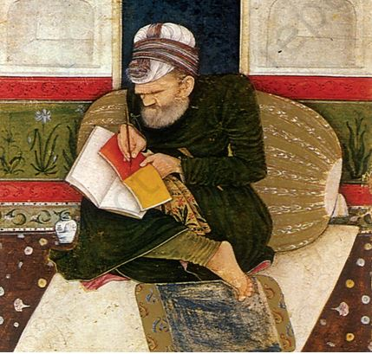  a) Why is this painting called miniature?  The painting is called miniature because it is small in size.  b) What is the scribe doing in the painting?  The scribe is making the copy of a manuscript. | 2 Marks
V | Answer in detail: - | 3 Marks
7 | How were the affairs of jatis regulated?  The affairs of jatis were regulated in the following way:  - Jatis formed their own rules and regulations.  - There was an assembly of elders called jati panchayat.  - It enforced the rules and regulations.  - Jatis were also directed to follow the rules of the village.  - Several villages were governed by a chieftain. (Any Three Points) | 3 Marks
 | SECTION - B (CIVICS) 10 Marks
VI | Choose the correct option: - | 1 Mark
8 | The first state to introduce Midday meal scheme.  (a)Kerala (b)Assam (c) Karnataka (d) Tamil Nadu | 1 Mark
VII | Fill in the blanks: - | 1 Mark
9 | _____________means equal right to vote.  Democracy. | 1 Mark
VIII | Match the Following : - | 2 Marks
10 | Prohibition of Discrimination (a) Dr B.R.Ambedkar | 1 Mark
11 | Indian Constitution (b) Article 15 | 1 Mark
(c) Article 13
10-b 11-a
IX | Answer in one or two sentences: - | 1 Mark
12 | What is Civil Rights Movement?  A movement that began in USA in 1950s in which African–American people demanded equal rights and an end to racial discrimination. | 1 Mark
X | Case Study Question: - | 2 Marks
13 | Carefully read the passage and answer the questions that follow:  When persons are treated unequally, their dignity is violated. The dignity of both Omprakash Valmiki and the Ansaris was violated because of the way in which they were treated. By picking on him and making him sweep the school, because of his caste, Omprakash Valmiki’s schoolmates and teachers hurt his dignity badly and made him feel as if he was less than equal to all other students in the school. Being a child, Omprakash Valmiki could do very little about the situation that he was in. It was his father who, on seeing his son sweep, felt angry by this unequal treatment and confronted the teachers. The Ansaris’ dignity was also hurt when persons refused to lease their apartments to them. However, when the property dealer suggested that they change their name, it was their dignity or self-respect that made them refuse this suggestion.  a. What did the teachers ask Omprakash Valmiki to do?  The teachers asked Omprakash Valmiki to sweep the school because of his caste.  b. How was Ansari’s dignity humiliated?  - The Ansaris’ dignity was humiliated when persons refused to lease their apartments to them.  - When the property dealer suggested that they change their name, it was their dignity or self-respect that made them refuse this suggestion. (Any one Point) | 2 Marks
XI | Answer in detail: - | 3 Marks
14 | Why is Universal Adult Franchise important in Democracy?  In a democracy, the Universal Adult Franchise is important because of the following reasons:  - Democracy is the government of the people, by the people, and for the people.  - Every adult irrespective of caste, creed, religion, region, sex, the rich or poor background is allowed to vote. This is called a universal adult franchise.  - The concept of the universal adult franchise is based on equality.  - In a democracy every citizen is equal. | 3 Marks
 | SECTION - C (GEOGRAPHY) 10 Marks
XII | Choose the Correct Option: - | 2 Marks
1 | The solid crust or the hard-top layer of the earth.  a) Hydrosphere b) Lithosphere c) Atmosphere d) Biosphere | 1 Mark
2 | The world of non-living elements are called ___________.  (a) Ecosystem (b) Biotic (c) Abiotic (d) Biosphere | 1 Mark
XIII | Fill in the blanks: - | 1 Mark
3 | _____________ interact with the environment and modify it according to their needs.  Human beings | 1 Mark
XIV | Match the following: - | 1 Marks
4 | Human environment a) Road | 1 Mark
b) Community
4-b
XV | Answer in one or two sentences: - | 1 Mark
5 | Give two examples of natural environment.  Land, Air, Water (Any two) | 1 Mark
XVI | Answer the following questions: - | 2 Marks
6 | Draw and label the diagram of the domains of Environment.  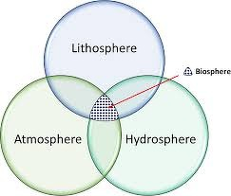 | 2 Marks
XVII | Answer in detail: - | 3 Marks
7 | What is lithosphere?  - Lithosphere is the solid crust or the hard-top layer of the earth.  - It is made up of rocks and minerals and covered by a thin layer of soil.  - It is an irregular surface with various land forms such as mountains, plateaus, plains, valleys, etc. | 3 Marks

